If the field ‘Set Subsequent Resource’ is put into the Resources Table as shown below, as opposed to the Products Table, then the Reset Subsequent Resource option must be put into the Products or Orders Table and NOT the Resources Table. The reset option should be set on the first operation in the process routing which requires a different Resource Group to the operations affected by the Subsequent Resource Constraint. This will allow later operations to be scheduled on a different resource than that chosen initially.

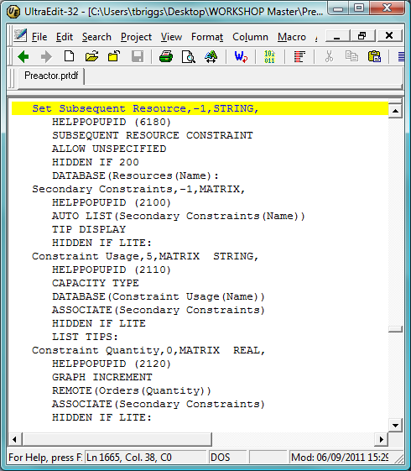

The field is set with the same resource name; i.e.

Lathe = Lathe (See below)

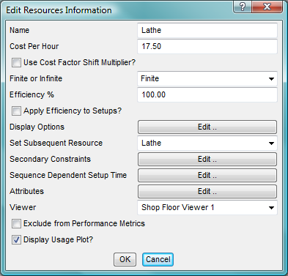

All Resources within the group should be set in the same way. There are 3 groups set as below (Turning Machines, Mills & Drills)

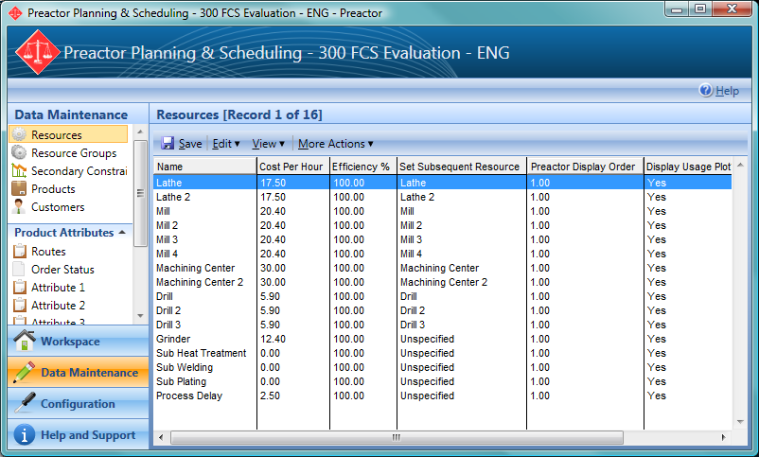

The Product has been set up with the first 3 operations being Turning jobs, the second 3 being milling jobs and the last 2 being drill jobs.

With the ‘Set Subsequent Resource’ field in the Resources Table set to continue on the same resource if selected, a job that has any operation that CAN be scheduled on that resource will ONLY be scheduled on that resource once the first operation has been allocated

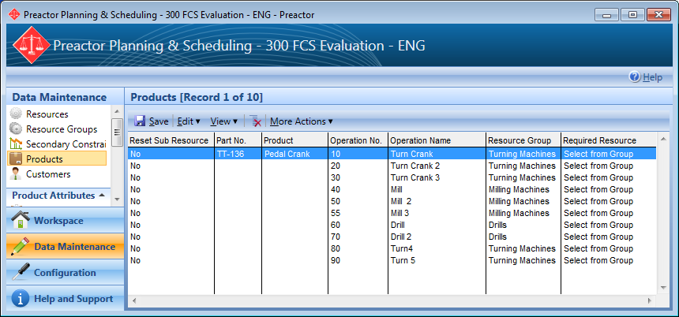

Each Order for the Product (TT-136) is scheduled onto the same Resource within each group and any operation requiring a Turning Machine will go on to the resource first used; thus the last operation step (80) requires a Turning Machine and will go onto the same resource as the first 3 operations.

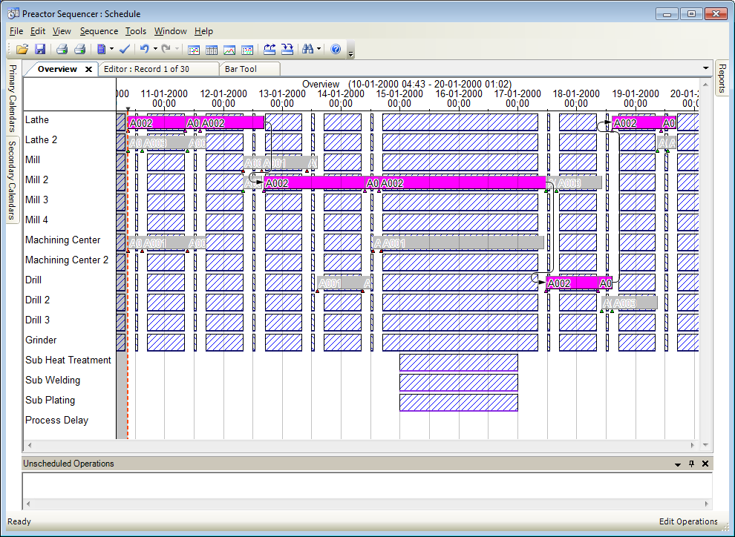

The first resource in the process route NOT using the Turning Machines Group is here configured as Resetting the Subsequent Resource

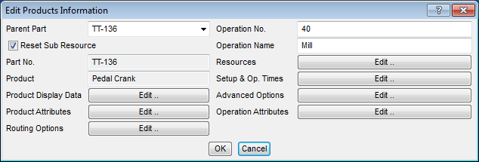

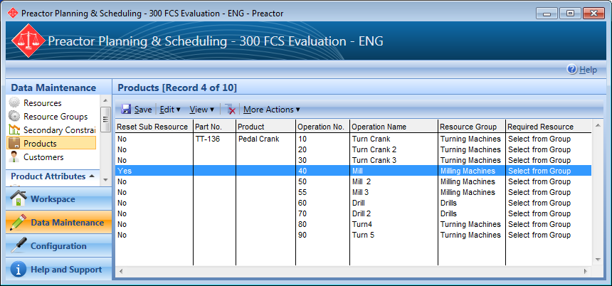

The last 2 operations, although on the same resource will not be forced onto the resource used by the first 3 (See below)

